Unit 1 - SEMICONDUCTING MATERIALS
Course objective – To enlighten the students on the principles of semiconductor materials and electron transport properties
Course Outcome – Students will be able to be familiar with the functioning of semiconductors
PART - A

1 | What is semiconductor?  1.The materials in which the electrical conductivity lies between conductors and insulators are called semiconductors.  2.They have resistivity value between 10–4 to 0.5 mΩ .  3.The electrical conductivity of semiconductor increases, when we added to impurities and by increasing the temperature and it is contrary to the metals.  4.They have negative temperature Coefficient of resistance and which are formed by covalent bonds | CO1 | K1
2 | Write the properties of a semiconductor.  1.They are formed by covalent bonds.  2.They have small energy gap.  3.They have an empty conduction band and almost filled valence band 0K.  4.They have negative temperature coefficient of resistance.  5.They resistivity of semiconductors lies between a semiconductor and Insulator. (10–4 to 0.5 Ohms m)  6.At 0 K it behave as insulator. | CO1 | K1
3 | Mention any Four advantages of semiconducting materials.  1.Semiconductors are smaller in size and use less power than other devices.  2.Semiconductors can be made to conduct electricity under certain conditions, such as heat, light, or voltage.  3.Impurities can be added to semiconductors to create new energy levels and alter their conductivity.  4.Semiconductors have a high melting point and low band gap energy, making them suitable for high-temperature applications. | CO1 | K1
4 | For an intrinsic semiconductor with a band gap of 0.7eV, determine intrinsic carrier concentration at T = 300K if mh*= 6me*.  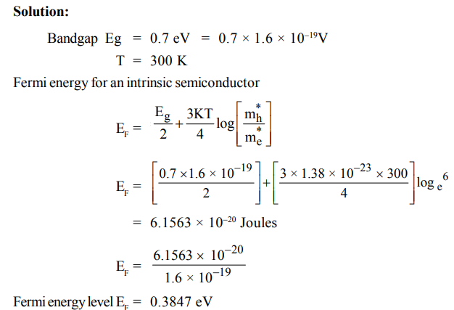 | CO1 | K3
5 | What are the differences between elemental and compound semiconductors?  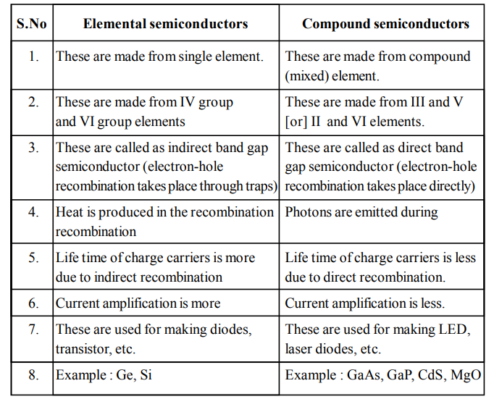 | CO1 | K2
6 | Compare intrinsic and extrinsic semiconductor.(Write the previous answer) | CO1 | K2
7 | Write an expression for the concentration of electrons in the conduction band of an intrinsic semiconductor.  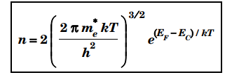 | CO1 | K2
8 | Write the expression for the concentration of holes in the valence band of an intrinsic semiconductor.  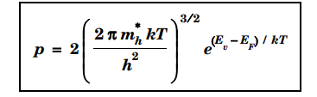 | CO1 | K2
9 | Write the expressions for carrier concentration in n-type and p-type semiconductor.  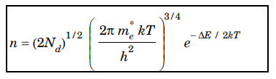  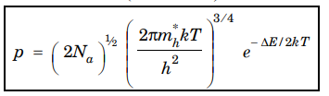 | CO1 | K2
10 | Define Fermi level in the case of semiconductors. Mention its position in intrinsic and extrinsic semiconductor at 0K.  In a semiconductor, the Fermi level is the energy level that represents the highest occupied electron state at absolute zero temperature  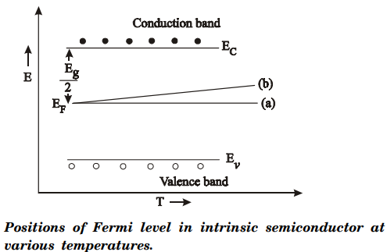  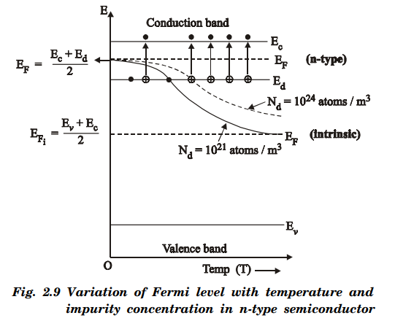  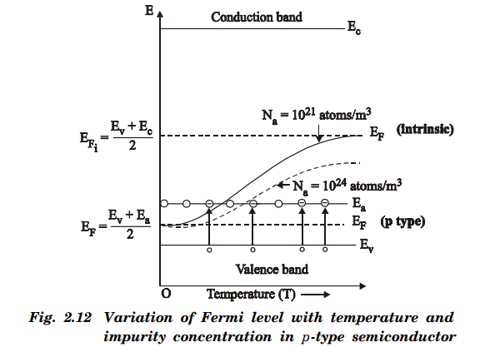 | CO1 | K1
11 | Write an example for pentavalent and trivalent impurities.  Pentavalent Impurities :Arsenic,Antimony,Bismuth  Trivalent Impurities:Aluminium,Indium,Gallium | CO1 | K1
12 | Name any two compound semiconductors with applications.  GaAs, GaP- These are used for making LED, laser diodes | CO1 | K1
13 | With increase of temperature the conductivity of a semiconductor increases. Why?  With increase of temperature the conductivity of a semiconductor increases because they exhibit negative temperature coefficient of resistance. | CO1 | K1

14 | Define Hall-effect and Hall Voltage.  When conductor (metal or semiconductor) carrying a current is placed in a transverse magnetic field, an electric field is produced inside the conductor in a direction normal to both the current and the magnetic field. This phenomenon is known as “Hall effect” and the generated voltage is called “Hall voltage” | CO1 | K1
15 | Mention the Uses of Hall effect.  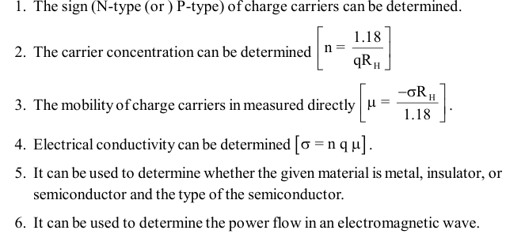 | CO1 | K1

